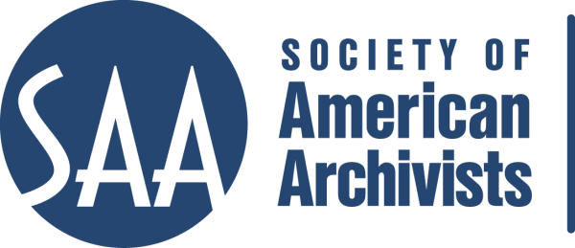

Society of American Archivists
Committee on Education Meeting
Wednesday, August 14, 2014
New Orleans, Louisiana

Agenda

8:00 a.m. to 10:00 a.m.

Welcome and Introductions

Present were Julie Graham (Chair), Jamie Roth (Vice Chair), Lorraine Dong, Naomi Nelson, Jennifer Pelose, and Shelby Sanett, committee members; Marty Oliff, Alison Clemens, Erin Faulder, Morgan Gieringer incoming committee members; Lori Lindberg, Chair, DAS Subcommittee; Geof Huth, Council liaison; Ania Jaroszek, Education Coordinator; and Solveig De Sutter, Director of Education. Absent: Kimberly Anderson, David Kay, Heather MacNeil, and Ellen Swain.

Approval of the Minutes from the March 2014 meeting.

Review and Approval of the Agenda.

SAA Council Liaison, Geof Huth provided an update from the New Orleans Council meeting.

DAS Subcommittee (DAS SC) Chair, Lori Lindberg provided an update on DAS, including the status of courses and exams, the status of the Comprehensive Examination, and DAS Subcommittee recommendations regarding examination policies.

- DAS SC completed creation of 115 items for the comprehensive examination at its February meeting and worked with the psychometrician to create data that allowed her to arrive at the minimal passing rate (using the Engoff method) for the comprehensive exam.
- The Subcommittee meets monthly via conference call to continually evaluate course content, course examinations, and revisions, developed a checklist for instructors and a course maintenance chart for the DAS Curriculum.
- Subcommittee member liaisons and staff scheduled and participated in numerous conference calls with developers and/or instructors to guide revisions of existing and development of new courses.

- Arrangement and Description for Electronic Records revised into two one-day courses (Prom)
- Legal Issues in Digital Archives revised into one course on copyright and one course on privacy and confidentiality (Briston/McKay)
- Digital Forensics for Archivists revised into two one-day courses (Lee/Woods)
- Thinking Digital web seminar (G. and J. Colati)
- Managing Electronic Records in Archives and Special Collections revised into a one-day course.
- Viewshare web seminar in collaboration with Library of Congress
- Accessioning and Ingest of Electronic Records

DAS SC recommended to CoE:

If someone takes a challenge exam and fails, he/she has to attend the course before a retake is allowed for that particular course.

CoE accepted this recommendation.

CoE was asked by staff to create a policy regarding unsuccessful completion of the Comprehensive Examination and decided on the following:

If a student fails the Comprehensive Examination s/he may retake the examination at a fee. Subsequent retakes must be preceded by additional course work based on the area of weakness identified.

CoE reviewed the Education Staff report and had few questions; this was followed by and an update on the Arrangement and Description Track Progress.

The Pre-conference Call for proposals process was viewed and discussed.

Exhibit Hall and Career Center Staffing was discussed and agreed to.

Meeting was adjourned at 10:00 a.m.

DAS Faculty Session

10:00 a.m. to Noon

Twelve faculty members attended and were updated on the DAS Curriculum development. This was followed by discussion about challenges including AV set up at host institutions, sustainability of the DAS program, and the large range of experience students in the classes possess.

